1. **Create a Database**

* UserTBL(username, password,displayname)
* Add few records to the table

|  |  |  |
| --- | --- | --- |
| **Username** | **Password** | **DisplayName** |
| Admin | Admin | Administrator |
| Mod | Mod | Moderator |

1. **Create a login.jsp as following:**

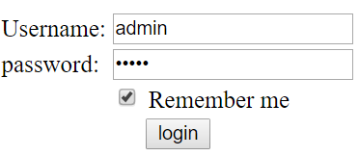

1. **When user click login**
   * IF username and password correct -> redirect user to Detail.jsp . Otherwise stays in login.jsp
   * If User try to access Detail.jsp without login -> redirect user back to the login.jsp. However if user checked to ‘Remember me’ in the previous login. System must allow user to access the page without requiring login again.
2. **The detail page displays the attr DisplayName of the corresponding username:**

